ITA0601 – MACHINE LEARNING
LAB EXPERIMENTS
Exp-2: Candidate Elimination Algorithm
Aim:
To implement and demonstrate the Candidate Elimination Algorithm using a training dataset stored in a CSV file and obtain the Specific Boundary (S) and General Boundary (G), representing all hypotheses consistent with the training examples.
Procedure:
- Create a CSV file containing the training dataset.
- Import the pandas and numpy libraries.
- Read the dataset from the CSV file.
- Separate the attributes (X) and target class (Y).
- Initialize:
  - Specific Hypothesis (S) with the first positive example.
  - General Hypothesis (G) with the most general hypothesis.
- Process each training example:
  - If the example is positive, generalize S where necessary and update G.
  - If the example is negative, specialize G to exclude the negative example while remaining consistent with S.
- Remove duplicate and unnecessary hypotheses from G.
- Display the final Specific Boundary (S) and General Boundary (G).
Python Code:
import pandas as pd
import numpy as np
data = {
'Sky': ['Sunny', 'Sunny', 'Rainy', 'Sunny'],
'AirTemp': ['Warm', 'Warm', 'Cold', 'Warm'],
'Humidity': ['Normal', 'High', 'High', 'High'],
'Wind': ['Strong', 'Strong', 'Strong', 'Strong'],
'Water': ['Warm', 'Warm', 'Warm', 'Cool'],
'Forecast': ['Same', 'Same', 'Change', 'Same'],
'EnjoySport': ['Yes', 'Yes', 'No', 'Yes']
}
df = pd.DataFrame(data)
print("Training Dataset:\n")
print(df)
concepts = np.array(df.iloc[:, :-1])
target = np.array(df.iloc[:, -1])
def learn(concepts, target):
specific_h = concepts[0].copy()
general_h = [["?" for i in range(len(specific_h))]
for i in range(len(specific_h))]
for i, h in enumerate(concepts):
if target[i] == "Yes":
for x in range(len(specific_h)):
if h[x] != specific_h[x]:
specific_h[x] = "?"
general_h[x][x] = "?"
elif target[i] == "No":
for x in range(len(specific_h)):
if h[x] != specific_h[x]:
general_h[x][x] = specific_h[x]
else:
general_h[x][x] = "?"
general_h = [g for g in general_h if g != ["?"] * len(specific_h)]
return specific_h, general_h
s_final, g_final = learn(concepts, target)
print("\nFinal Specific Hypothesis:")
print(s_final)
print("\nFinal General Hypothesis:")
for g in g_final:
print(g)
Output:
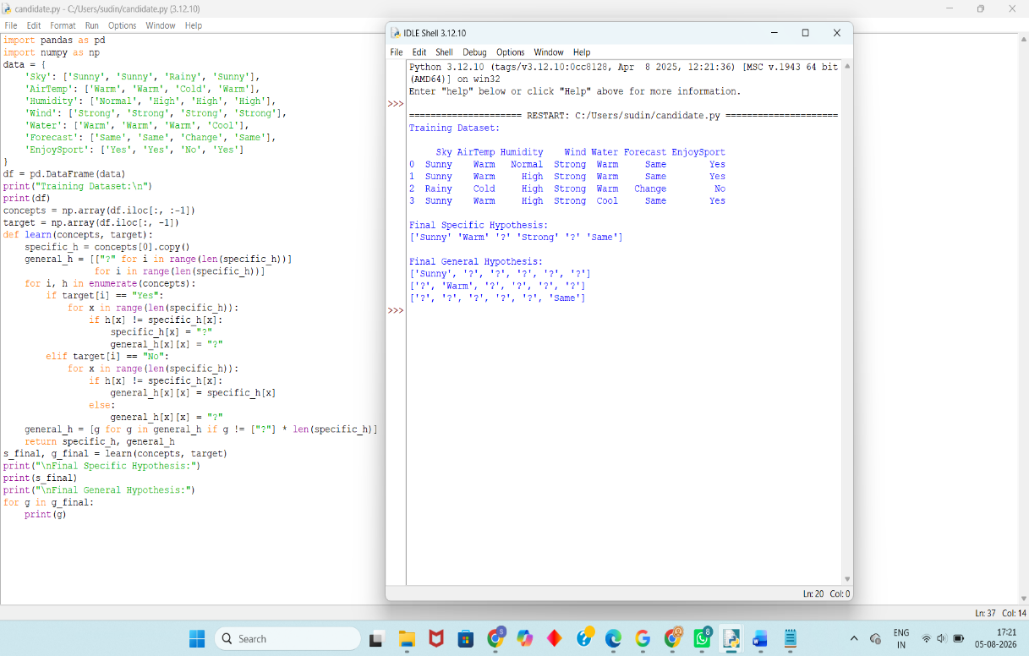
Result:
The Candidate Elimination Algorithm was successfully implemented using a CSV dataset. The algorithm determined the Specific Boundary (S) and General Boundary (G), which together represent the version space, i.e., the set of all hypotheses consistent with the given training examples.

